**Sanika Kadam 2124UCSF1112**

**ASSIGNMENT NO.1**

**1. Introduction**

Install the Android SDK and developer tools and build a test project to confirm that those tools are properly installed and configured.

**2. Tools & Technologies Used**

* Android Studio
* Java/Kotlin (Specify the language used)
* Emulator or Physical Device (Medium Phone API )

**3. Procedure & Steps**

**Step 1: Create a New Project**

* Open Android Studio and create a new project.
* Select second page activity by app-activity-page you selected
* Set the project name and package name.
* Select the programming language (Java/Kotlin).
* 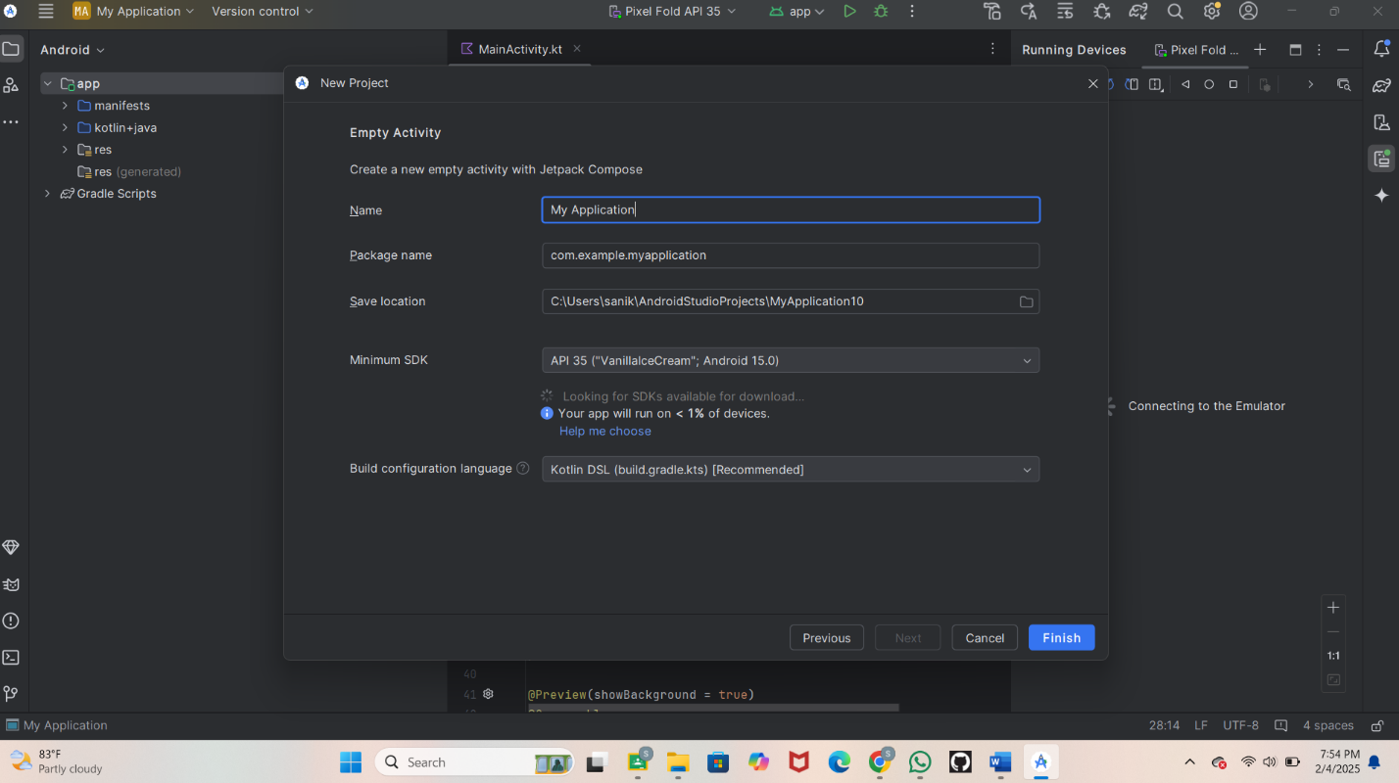

**Step 2 : Writing a code**

**Step : Running the Application on Emulator**

* Click on the **Run** button in Android Studio.
* Select the emulator and launch the app.

**Screenshot:** 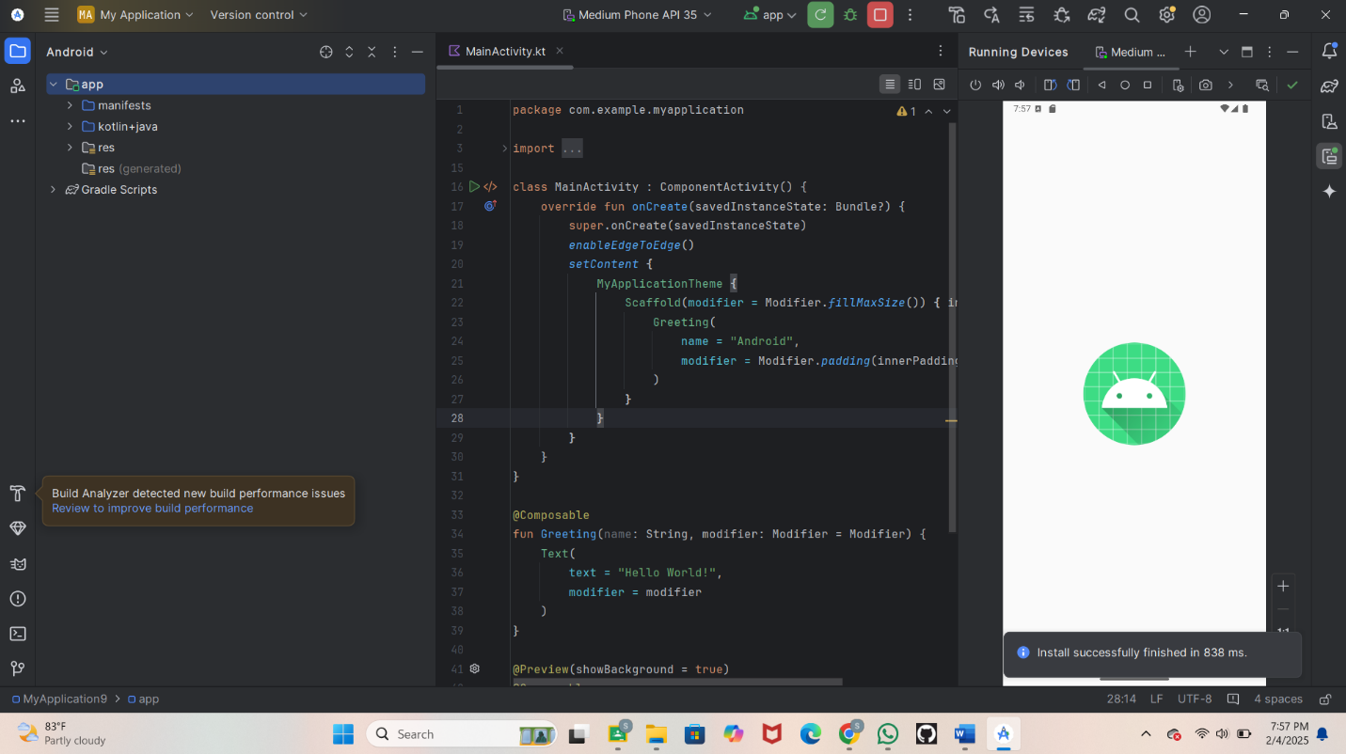

**Step 3: Testing & Output**

* Test different functionalities of the app.
* Capture the output results.
* **Screenshot:** 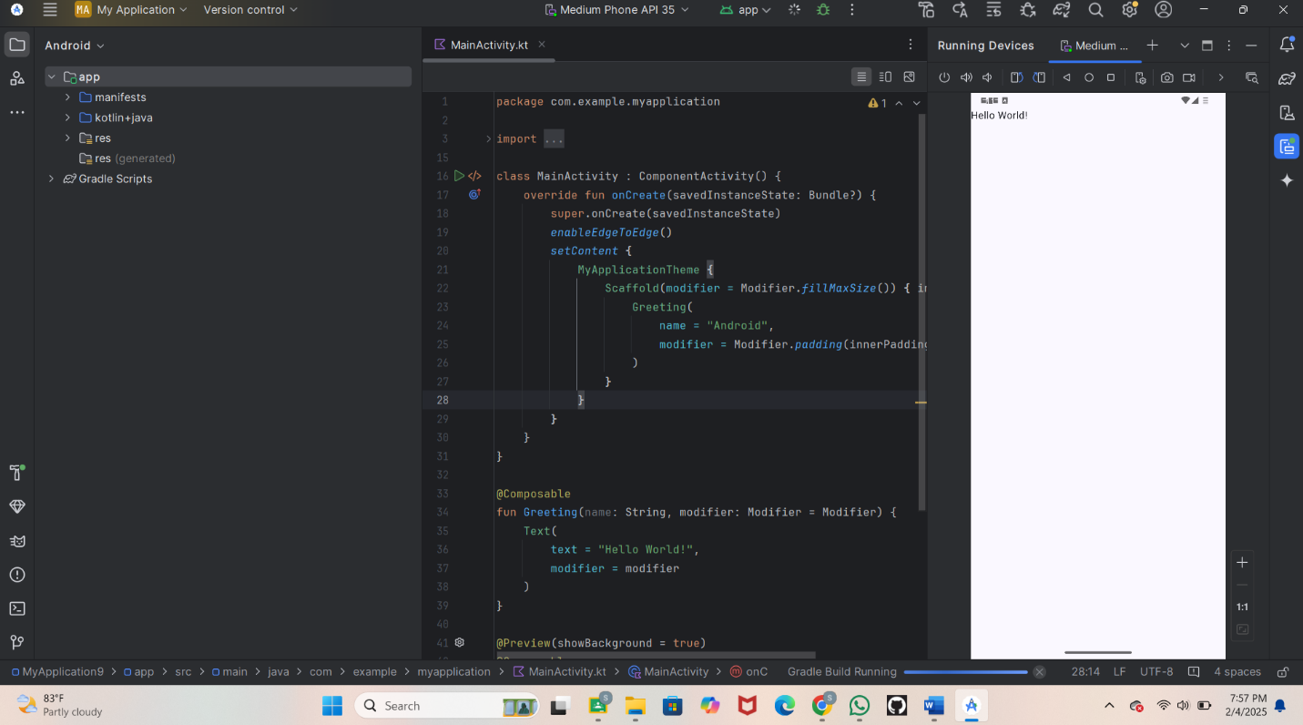

**4. Conclusion**

﻿Creating a "Hello World" app on Android Studio taught me the basics of Android development, along with coding in Java/Kotlin and designing the UI with XML. I faced challenges with setting up tools, the emulator, and Gradle errors, which I resolved by adjusting settings, sync.